Module 3 – Conversational AI Interface Development

Middleware Project – Task 2 Update

## Overview

This document describes the updates made in Task 2 of Module 3 for the TeamA IVR Modernization initiative. Task 2 focused on extending the middleware to support Conversational AI queries.

## Task 2 – Middleware Extension

### Features Implemented

1. **New API Route:** /ivr/conversation
   * Accepts JSON input with sessionId and query.
   * Example Request:

* {  
   "sessionId": "101",  
   "query": "Check my balance"  
  }

1. **Intent Detection:**
   * Uses detectIntent.js to identify the target service.
   * ACS service handles balance and recharge queries.
   * BAP service handles agent connection queries.
2. **Response:**
   * Returns JSON with sessionId and response message.
   * Example Response:

* {  
   "sessionId": "101",  
   "response": "Your account balance is ₹500."  
  }

1. **Integration:**
   * Integrated with existing ivrController.js and ivrRoutes.js.
   * Connected to updated ACS and BAP mock services.
2. **Testing:**
   * Endpoint tested successfully using Postman for multiple queries:
     + Balance Inquiry
     + Recharge
     + Agent Request
     + Unknown Query

## Directory Updates

middleware-project/  
├── controllers/  
│ └── ivrController.js # Handles DTMF and Conversational AI queries  
├── routes/  
│ └── ivrRoutes.js # API routes including /ivr/conversation  
├── services/  
│ ├── acsService.js # Mock ACS service updated for conversation handling  
│ └── bapService.js # Mock BAP service updated for conversation handling  
├── utils/  
│ └── detectIntent.js # Keyword-based intent detection module  
├── index.js # Main server file

## API Details

### POST /ivr/conversation

* **Request Body:**

{  
 "sessionId": "101",  
 "query": "Check my balance"  
}

* **Response Body:**

{  
 "sessionId": "101",  
 "response": "Your account balance is ₹500."  
}

### Intent Mapping Table

| Intent | Sample User Utterances | Target Service |
| --- | --- | --- |
| Balance Inquiry | “Check my balance” | ACS |
| Recharge | “Recharge my account” | ACS |
| Talk to Agent | “I want to talk to agent” | BAP |

## Testing Notes

* Endpoint tested using Postman.
* Verified correct responses for each query type.
* Response matches expected JSON structure.

## Space for Detailed Test Cases

**Test Case 1: Balance Inquiry**

**Endpoint**: POST /ivr/conversation

**Request Body:**

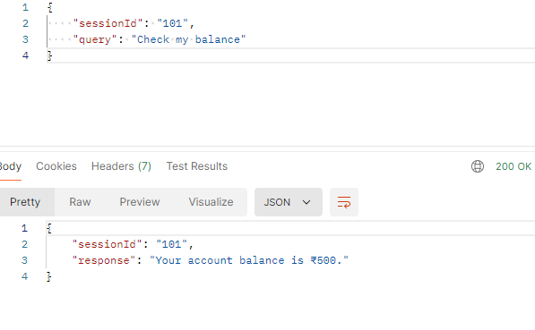

**Expected Response:**

**Automated Validations:**

* Status code is 200
* Response contains the correct sessionId
* Response message includes "balance" and the currency symbol "₹"
* Content-Type is application/json
* Response time < 2000ms

**Test Case 2: Recharge**

**Endpoint:** POST /ivr/conversation

**Request Body:**

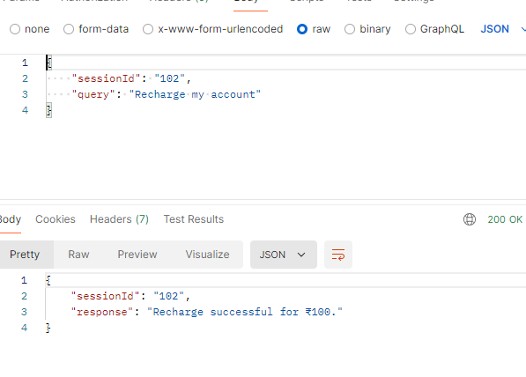**Expected Response:**

**Automated Validations:**

* Status code is 200
* Response contains correct sessionId
* Response message confirms recharge amount
* Content-Type is application/json
* Response time < 2000ms

**Test Case 3:**

**Endpoint:** POST /ivr/conversation

**Request Body:**

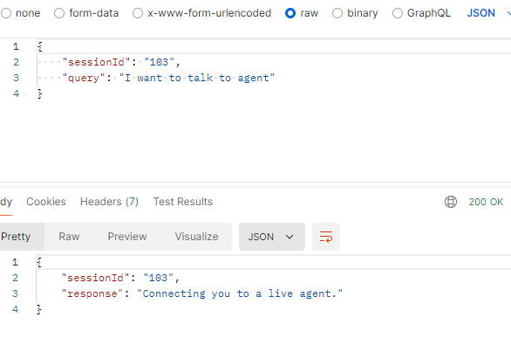

**Expected Response:**

**Automated Validations:**

* Status code is 200
* Response contains correct sessionId
* Response message indicates agent connection
* Content-Type is application/json
* Response time < 2000ms

**Test Case 4:**

**Endpoint:** POST /ivr/conversation

**Request Body:**

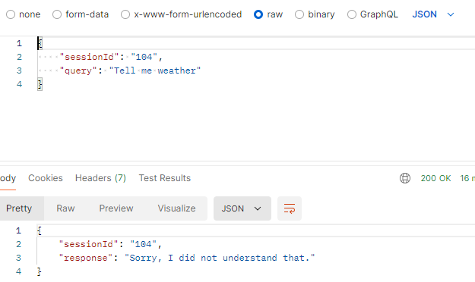

**Expected Response:**

**Automated Validations:**

* Status code is 200
* Response contains correct sessionId
* Response message indicates unrecognized query
* Content-Type is application/json
* Response time < 2000ms